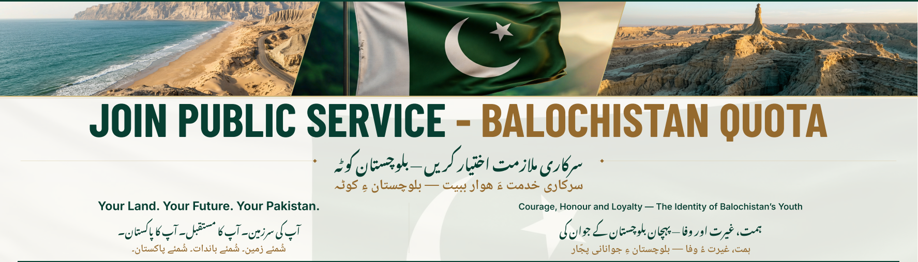
MINISTRY OF RAILWAYS
ISLAMABAD
POSITIONS AVAILABLE | BPS | Number of Vacancies | Age Limit | Last Qualification
Steno typist (BPS-14) | 14 | 01 | 18 – 35 Years | • Intermediate  • Minimum shorthand speed of 80 wpm and typing speed of 40 wpm.  • Must be computer literate.
Lower Division Clerk (LDC) (BPS-11) | 11 | 01 | 18 – 35 Years | Matriculation.  • Minimum typing speed of 30 wpm.  • Basic computer/MS Office literacy
Staff Car Driver  (BPS-04) | 04 | 01 | 18 – 35 Years | Primary pass school certificate.  • Must hold a valid driving license (LTV/HTV).  • Fully conversant with traffic rules and medically fit
Naib Qasid (BPS-01) | 01 | 03 | 18 – 35 Years | • Primary Pass

[
TERMS AND CONDITIONS
- Open quota as well as 5 % Minority and 10% women quota will be observed where applicable.
- Age limit: 18–30 years + 05 years (Specific additional relaxation for candidates from Baluchistan notified by Establishment Division dated 22.10.2026 & 27.10.2026.
- Upper age i.e. 35 years will be calculated as of the closing date of the advertisement.
- In case of ex-servicemen, the upper age limit is relaxed by 15 years or the number of years actually served in the Armed Forces of Pakistan, whichever is less.
- The age of Government servants and contract employees who have completed 2 years continuous Government service on the closing date of receipt of application is relaxed by 10 years up to the age of 55 years.
- The age relaxation for the disabled candidates is 10 years.
- The age of widow or child of deceased Civil Servant who has died during service is further relaxed by 05 years.
- Where a candidate is entitled to age relaxation under more than one category above, he shall be allowed relaxation in age only in one category.
- Transfer/Posting: The selected employees will be liable to serve within the Ministry of Railways, Islamabad.
- The selected candidate will be required to:-
  - Pass prescribed Medical Examination (under Ministry of National Health Services regulation and Coordination, Islamabad) and clearance by Security Agencies.
  - Undergo specified training, if any.

GENERAL INFORMATION
- Interested candidates are directed to submit their applications online at “National Job Portal” within closing date of application submission.
- Last date to apply is 11.11.2026.
- The following attested documents must be attached at NJP website:
- ​Educational Certificates (Primary/Middle/Matric 2nd Division/FA/FSc 2nd Division).
- Degree/Diploma (where required for the post) must be submitted along with the application form.
- ​CNIC and Domicile Certificate.
- ​Character Certificate.
- ​Passport-size photographs with blue background.
- The candidates who are serving in Railways or any other department shall upload their application along with NOC.
- Incomplete applications or applications carrying incorrect information shall be rejected.
- If any document provided by candidate is found bogus during the recruitment process and afterwards, the appointment will be treated as cancelled.
- No TA/DA shall be admissible for interviews.
- Walk in interviews shall be conducted.
- Recruitment as per Establishment Division Office Memorandums dated 22.10.2026 & 27.10.2026 under the supervision of the Selection Committee, will take place at Divisional Superintendent office, Pakistan Railways, Quetta.

(Dy. Director Recruitment & Selection)
Ministry of Railways
Islamabad.
Ph. No. 051-9204154

